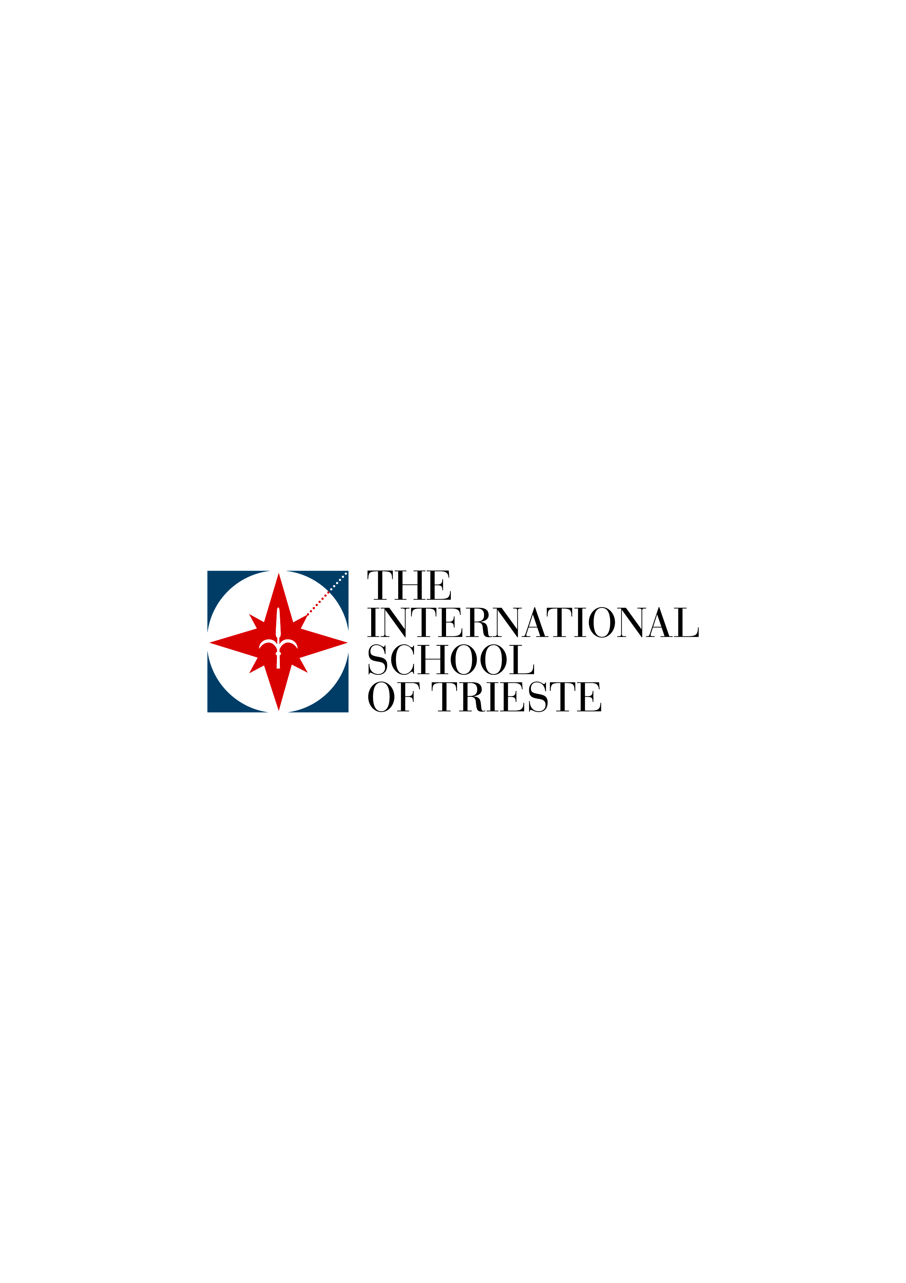

TERMS AND CONDITIONS 2025- 2026 SCHOOL YEAR

2025 – 2026 SCHOOL FEES

Kinder 2 (part-time) € 4,866.00 *
Kinder 2 full time and Kinder 3&4 € 8,110.00
Kindergarten € 9,120.00
Elementary (Gr. 1-5) € 10,290.00
Middle School (Gr. 6-8) € 10,740.00
High School € 11,390.00
High School Distance Learning € 15,950.00
First Enrolment Fee (per student) € 400.00
Re-enrolment Fee € 260.00
Afternoon Supervision € 495.00
Bus shuttle Trieste (Piazza Oberdan) € 1,190.00 **
Bus shuttle Ronchi dei Legionari € 2,590.00 **
Bus shuttle Udine € 3,110.00 **

*The part-time option, with the relative reduction of the school fee, is only available for Kinder 2.
** The cost of transportation is based on the number of students using the service during the current school year. The school will communicate possible adjustments depending on the number of students using the service next year.

TERMS AND CONDITIONS
Terms of Payment:
- The school annual fee refers to the amount owed for a full school year and becomes due in its entirety upon enrolment. The annual fee is non-negotiable and no reductions or reimbursements will be provided in the case of absences of the enrolled student. Fees can be paid by instalment but that does not remove the obligation for the full payment of the annual fees.
- Annual Fees can be paid through bank transfer only:
- In one payment by 30 September, or
- In ten instalments of equal value to be paid by the 15th day of each month starting from September (15.09.25, 15.10.25, etc.).
- The enrolment fee and annual fees for a third child enrolled at the school are subject to a 50% reduction.
- In the case of a failure to make payment of two instalments, even if they are not consecutive payments, the School will be entitled to a legal recovery of the outstanding school fees and to suspend school attendance of the Student with a 30-day notice.
- In the case of arrears or failure to pay the Fees, both parents, having signed the enrolment agreement, shall be held jointly responsible.

General Regulations:
- The annual fee includes daily meals and the use of textbooks on loan, which remain the property of the School.
- Upon submission of the annual enrolment form, the annual fees noted above are entirely owed by the family. However, should a family, with valid and motivated reasons approved by the Head of the Administration Office of the school, withdraw their children before the end of the school year for which they have submitted enrolment, the School may provide them with a reduction on the annual fee as follows:
- A discount of nine instalments of the annual fee if the withdrawal takes place prior to 30 April preceding the start of the school year regulated by these Terms & Conditions, as the School must make the proper plans for the class.
- Then, of eight instalments of the annual fee if the withdrawal takes place before 30 June.
- Of seven instalments of the annual fee if the withdrawal takes place between the subsequent 1 July and 31 August.
- Finally, a discount of six instalments of the annual fee if the withdrawal happens between the subsequent 1 September and 31 December.
Under evidenced and exceptionally severe circumstances, the Board of Directors can resolve to modify the Terms and Conditions of this Clause 7.
- By signing the enrolment form, the family acknowledges that they have read the School Handbook available on the School website (www.istrieste.org) and agree to respect the regulations and responsibilities outlined within.
- The Board of Directors sets the Annual Fees and updates them each year. Under exceptional circumstances, the Board of Directors can modify the Fees during the year.

